Experiment 1

Setting Up Python Environment and Libraries – Jupyter Notebook

Aim: To configure Python, Jupyter Notebook, and verify the installation of essential data analytics libraries using the driver_standings.csv dataset.

Procedure:

Install Jupyter Notebook using the command pip install notebook.

Install the required libraries (pandas, numpy, and matplotlib) if they are not already installed.

Create a new Jupyter Notebook and rename it appropriately.

Import the required libraries such as Pandas, NumPy, and Matplotlib.

Verify the successful installation of the libraries by checking their versions.

Load the driver_standings.csv dataset using the read_csv() function.

Display the first few records of the dataset.

Examine the dataset using info(), shape, columns, and describe().

Identify missing values and duplicate records.

Perform basic NumPy operations.

Generate a histogram and a bar chart to visualize the dataset.

Code:

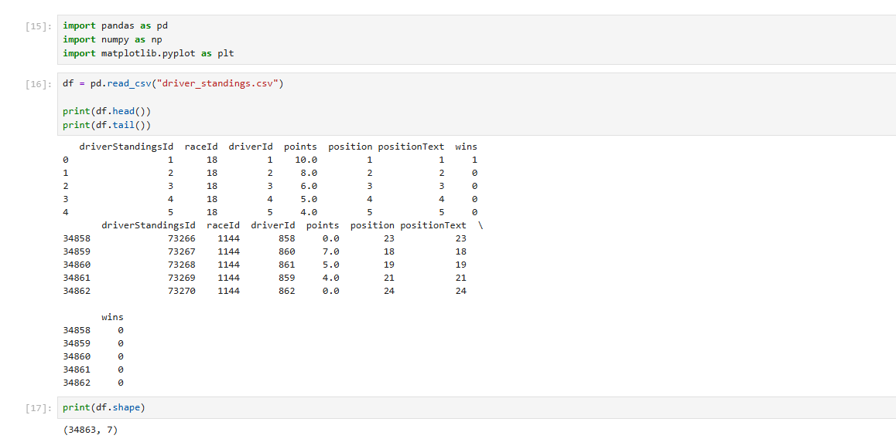
- Imported libraries
- Read csv and displayed the first and last 5 rows of the table
- Displayed the shape of the table in rows and columns
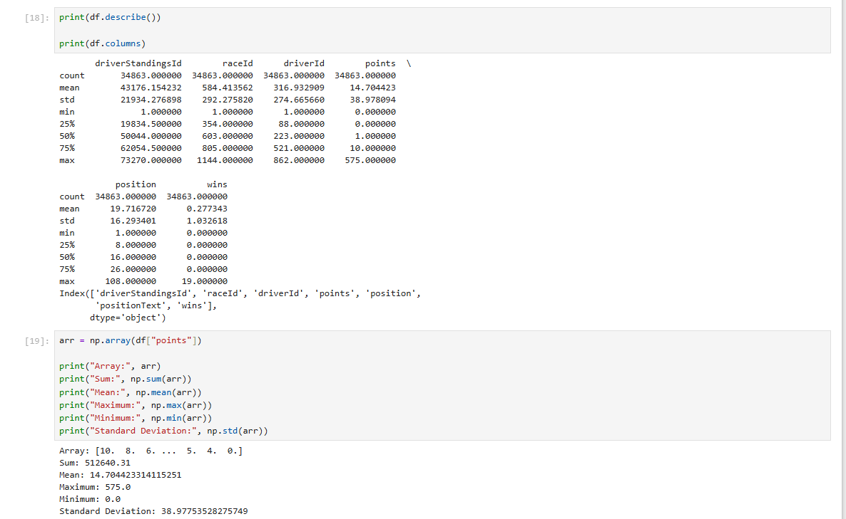
- Described the table and displayed all the column names
- Printed array, sum, mean, max, min, sd
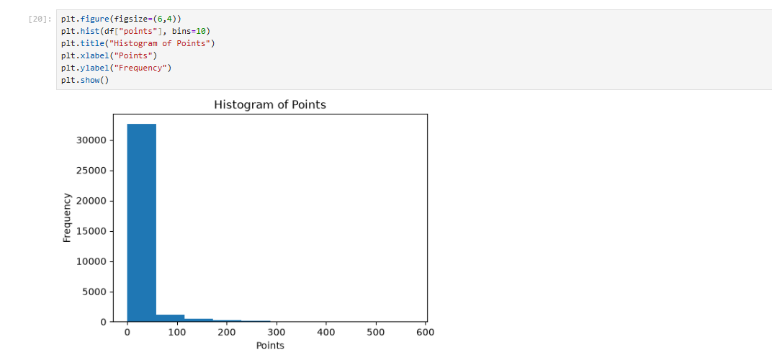
- Displayed the Histogram of the height column
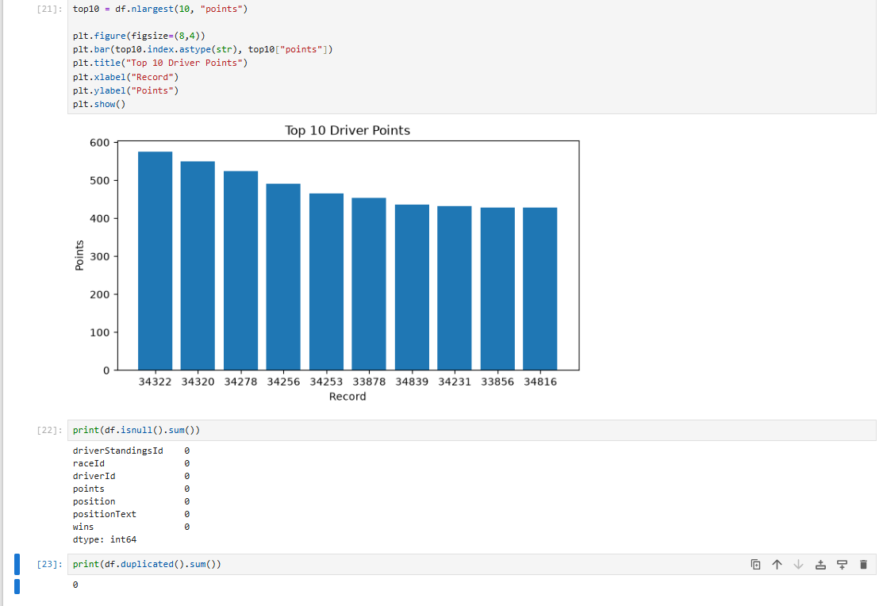

- Checked if there are any null values
- Checked if there are any duplicate values

Experiment 2: Exploratory Data Analysis (EDA) – Data Import and Export

Aim:

To import the driver_standings.csv dataset, perform basic exploratory data analysis using Pandas, identify missing values and duplicate records, and export the processed dataset into different file formats.

Procedure:
- Import Pandas and SQLite3 libraries.
- Load the driver_standings.csv dataset.
- Display the first and last five rows.
- Display dataset information, shape, column names, and data types.
- Generate statistical summary.
- Check for missing values.
- Detect duplicate records.
- Save the dataset as an Excel file.
- Create an SQLite database and store the dataset.
- Export the dataset to CSV, Excel, and JSON formats.
- Verify the exported files.

Code:

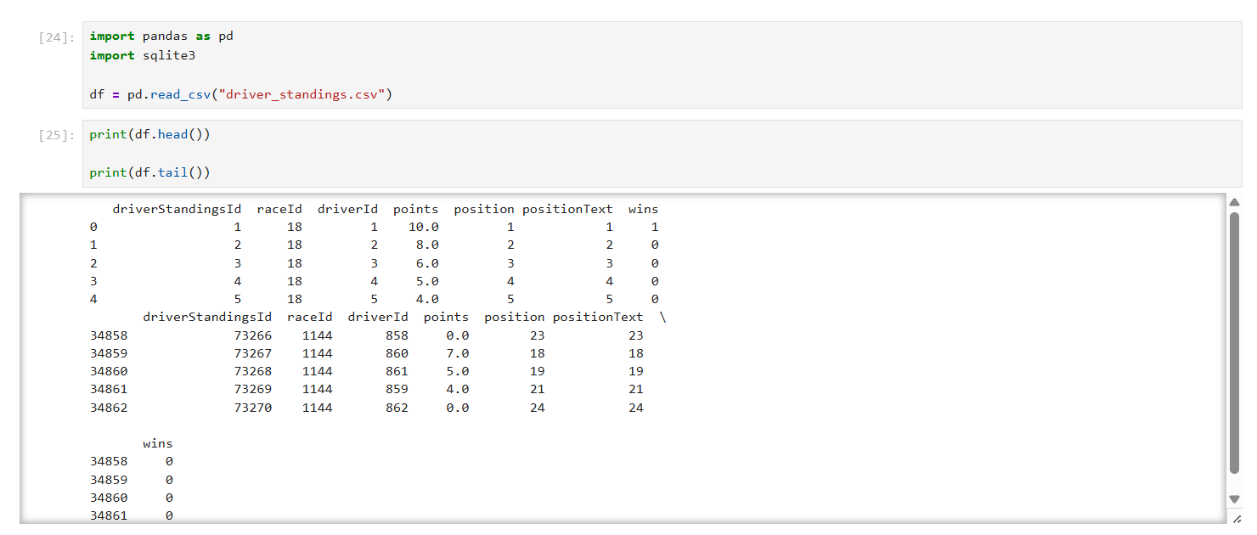
- Imported packages and read the dataset
- Displayed the first and the last 5 rows of the dataset

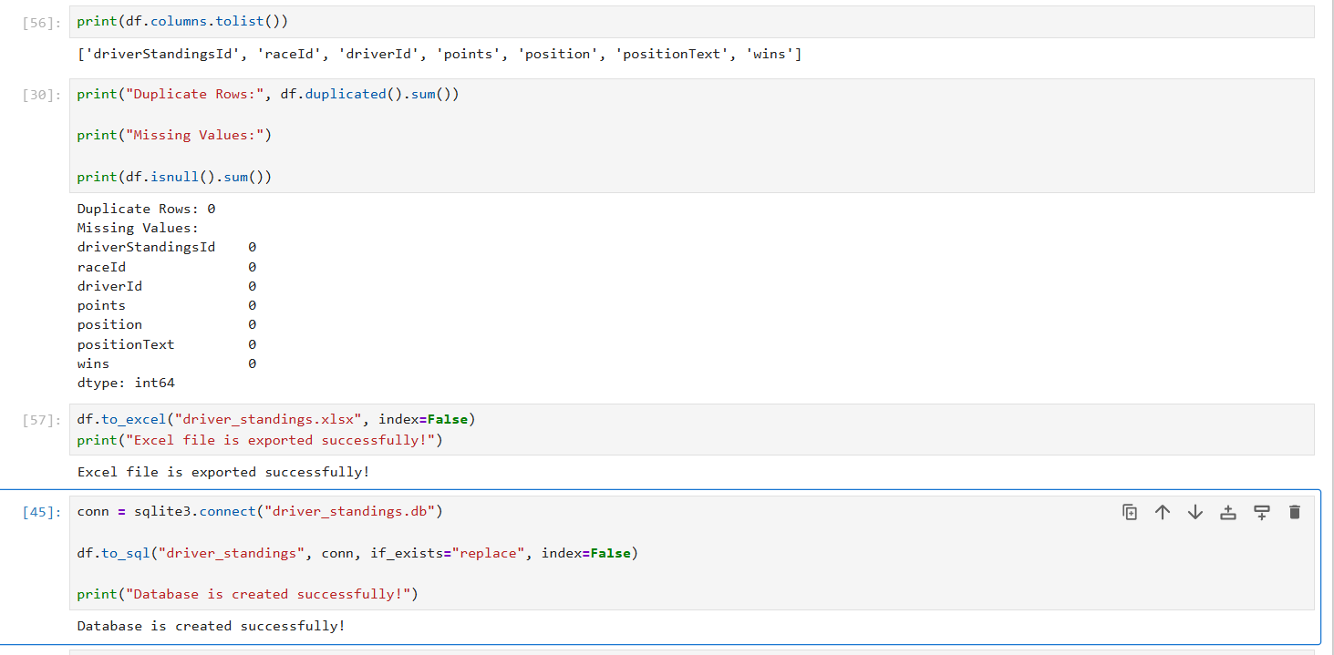
- Displayed the column name
- Checked if there are any duplicate or missing values In the dataset
- Saved the dataset as a excel file

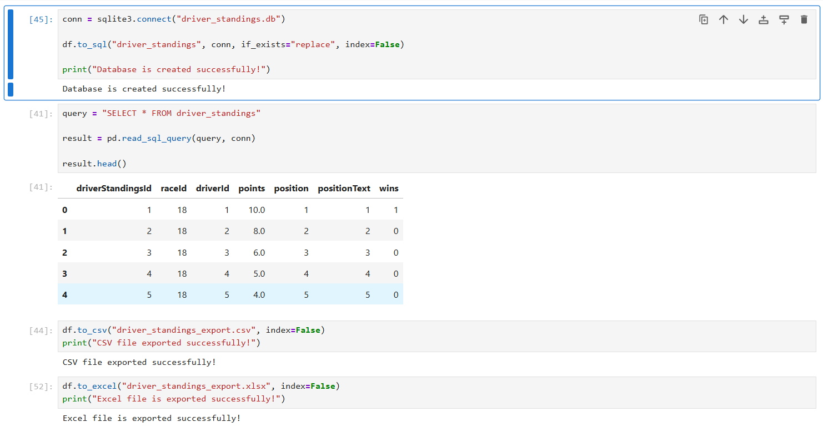

- Created SQlite Database
- Exported dataset to CSV, Excel, and JSON
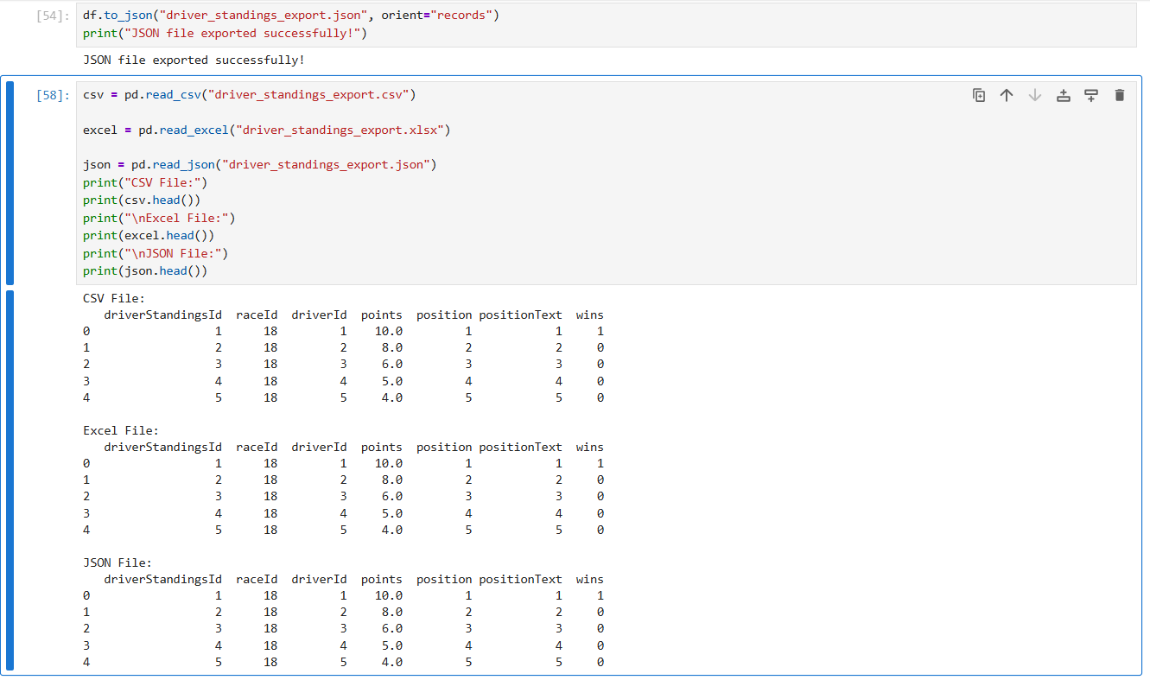
- Verified the exported CSV, Excel, and JSON files are read

